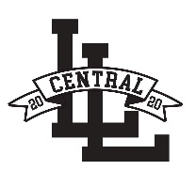Central Little League Sponsor Registration Form
Dear Potential Sponsor,
Company and individual sponsorship is one of the biggest reasons that our organization has been able to teach the children of our community the great game of Baseball. Central Little League Strives on getting the kids off the streets and on the fields. Teaching daily and life skills, as well as team building. Your sponsorship helps with uniforms, equipment, trophies, Snack Bar items, field repairs, insurance, and umpires. We offer Financial Assistance for low-income families. With your sponsorship, you can help us make the 2024 season a memorable one.
Thank You, Opening Ceremony is March 23rd 2024
Michelle Williamson, Central President
Sponsorship level desired (please circle):

The Single $25- $100 The Triple $300 (you must provide banner)
(name on Web site sponsor board) (name on web site sponsor board and team Plaque and display banner)

The Double $200 Home Run $400 and UP (we supply banner)
(name on web site sponsor board and team Plaque (name on web site sponsor board and team Plaque and display banner)

Sponsor Information:
Name______________________________________________________ Address____________________________________________________ City____________________ State_____ Zip code_______________
Contact person for advertising information (logos, banner info, etc.):
Name_______________________________ Phone#________________
Approved by: (Print Name) ____________________________________
Signature___________________________________
Central Little League is a 501(c)(3) Non-Profit Charitable Organization. Its EIN is 52-1234775
Sponsor Form and Checks can be mailed to:
Central Little League
P.O. Box 1514
Highland, Ca 92346-1514
for sponsorship questions, e-mail Socialbugshell@yahoo.com or Stephen91967@yahoo.com
For more Information, Phone Number: (909) 362-0538 Michelle OR (909) 362-9145 Steve

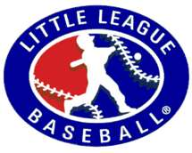 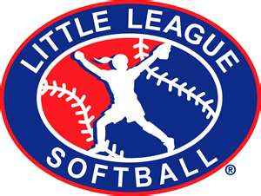 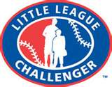 visit us at www.centralll.org

